LRFR Example Calculations

120 ft span with 5-WF66G girders at 6’ spacing with 3’ overhangs
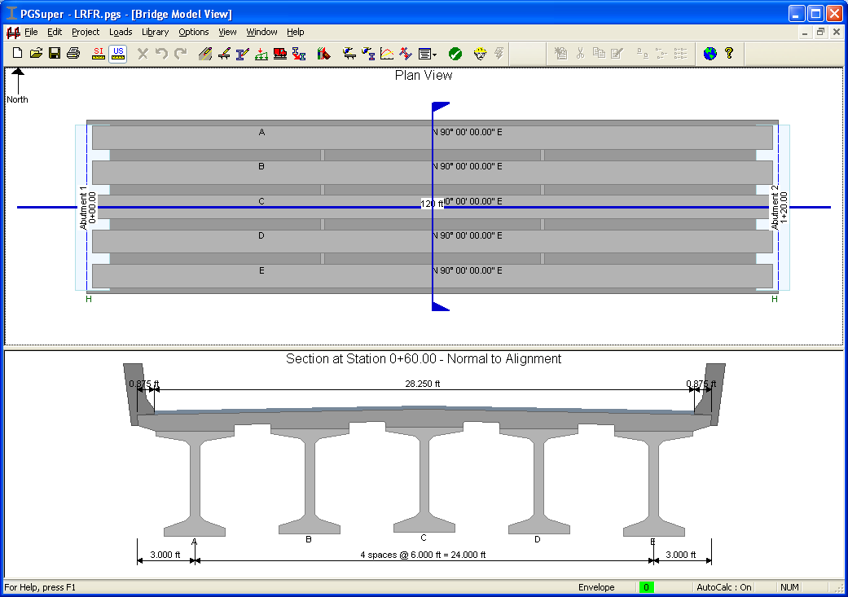

Properties
Girder f’_{ci} | 4.4 KSI
Girder f’_{c} | 5.5 KSI
Deck f’_{c} | 4.0 KSI
Straight Strands | 26
Harped Strands | 7
Temporary Strands | 0
Strand | 0.6” diameter, Grade 270
Deck Thickness | 7.5”
“A” Dimension | 11.25”
Sacrificial Depth | 0.5”
Future overlay | 2” thick at 140 PCF
ADTT one direction (assumed) | 1500

Rating of Exterior Girder

Design Rating – MBE 6A.4.3.1

6A.5.4.1 – Rate at the Strength I and Service III limit states

Condition Factor, φ_{c} = 1.0 (Table 6A.4.2.3-1, Good or Satisfactory)

Rating for Flexure

Rating location = mid-span

System Factor, φ_{s} = 1.0 (Table 6A.4.2.4-1, All other girder bridges and slab bridges)

Moments
M_{DC} = 3288.3 k-ft
M_{DW} = 216.4 k-ft
M_{LL+IM} = 1929.2 k-ft/girder (HL-93 loading)

Stresses – Bottom of Girder
σ_{DC} = 2.207 ksi
σ_{DW} = 0.118 ksi
σ_{LL+IM} = 1.055 ksi
σ_{PS} = -3.197 ksi

Load Factors – Strength Limit State (MBE 6A.4.2.2)
γ_{DC} = 1.25
γ_{DW} = 1.50 (wearing surface not field measured – would be 1.25 if it was field measured 6A.2.2.3)
γ_{LL} = 1.75 for Inventory (6A.4.3.2.2)
γ_{LL} = 1.35 for Operating (6A.4.3.2.2)

Note: LRFD load factors for DC and DW are 1.25/0.9 and 1.50/0.65 respectfully, where the larger value is used when the force effect contributes to the response being evaluated and the smaller value is used when it has the opposite effect. Use caution when taking factored limit state values from PGSuper.

Load Factors – Service Limit State (MBE 6A.4.2.2)
γ_{DC} = 1.0
γ_{DW} = 1.0
γ_{LL} = 0.8

Dynamic Load Allowance = 33% (MBE 6A.4.3.3 and LRFD 3.6.2) – Already included in M_{LL+IM} above.

Live Load Distribution Factor, gM = 0.564 (computed by PGSuper, included in M_{LL+IM} above).

Moment Capacity, 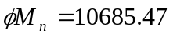k-ft (computed by PGSuper)

6A.5.7 – Minimum reinforcement
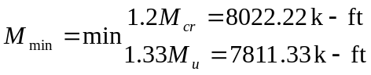
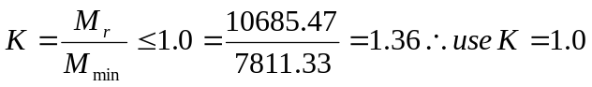

Rating Factor
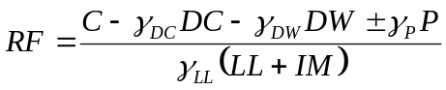
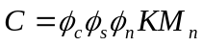 Strength I limit state
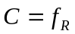, Service III limit state

Inventory Rating – Strength I Limit State
k-ft

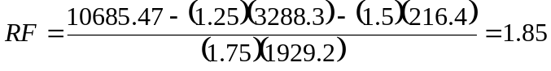

Inventory Rating – Service III Limit State
C = 0.0 ksi (WSDOT BDM 5.2.3B)

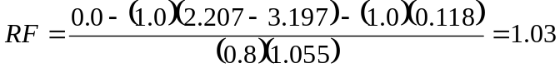

Operating Rating – Strength I Limit State
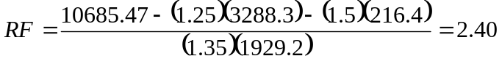

Rating for Shear

MBE 6A.5.9, In-service concrete bridges that show no visible signs of shear distress need not be checked for shear when rating for the design or legal loads.

There are two interpretations of this requirement; 1) this is a design rating and the bridge has not yet been constructed therefore it is not in service and must be rated for shear, 2) just after the bridge is put into service, it is a new bridge so there should not be visible signs of shear distress and therefore it does not need to be rated for shear. For sake of example, the rating factor will be computed here.

Note: Rating for shear at the Design and Legal Load condition will be computed at the user’s option in PGSuper.

Rating location = 0.3L
Note: 0.3L is a representative point chosen for purposes of developing sample calculations.

System Factor, φ_{s} = 1.0 when evaluating shear at the strength limit state (MBE 6A.4.2.4)

Shears
V_{DC} = 46.28 kip
V_{DW} = 3.02 kip
V_{LL+IM} = 51.77 kip/girder

Live Load Distribution Factor, gV = 0.671 (computed by PGSuper, included in V_{LL+IM} above).

Shear Capacity, 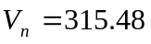kip
φ = 0.9
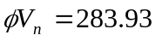

Inventory Rating – Strength I Limit State
kip
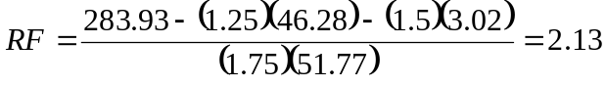

Operating Rating – Strength I Limit State
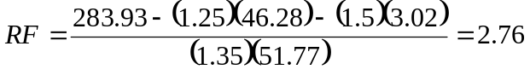

MBE 6A.5.9 – When using the Modified Compression Field Theory (MCFT) for the evaluation of concrete shear resistance, the longitudinal reinforcement should be checked for the increased tension caused by shear, in accordance with LRFD Design Article 5.8.3.5

At face of support, 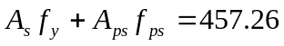kips and 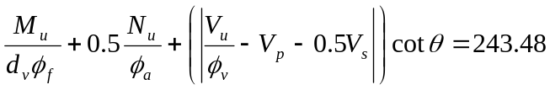kips, therefore 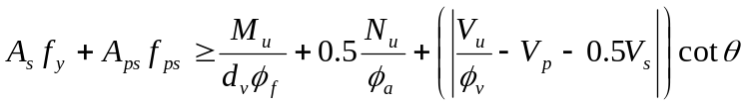and the requirements of LRFD 5.8.3.5 are satisfied.

Legal Load Rating – 6A.4.4

Note: This evaluation is not necessary because this bridge passes the HL-93 screening at the Inventory level. (MBE 6A.4.3.1)

Evaluate Strength I – 6A.5.4.2.1
Evaluate Service III – 6A.5.4.2.2a – optional and use γ_{L} = 1.0

Dynamic Load Allowance (6A.4.4.3)
IM = 33%

Note: IM could be 10% or 20% based on riding surface condition (see C6A.4.4.3)

Load Factors
Strength I Limit State – Routine Commercial Traffic (6A.4.4.2.3a)

For ADTT = 1500

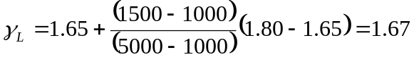

Strength I Limit State – Specialized Hauling Vehicles (6A.4.4.2.3b)

For ADTT = 1500

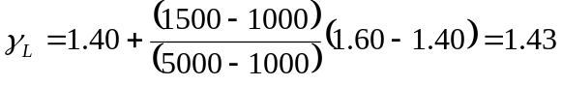

Live Load 6A.4.4.2.1

Maximum effect of AASHTO Type 3, Type 3S2, Type 3-3 and Notional Rating Load (NRL).

Notes:
- for continuous systems, include 75% of two Type 3-3 with 0.2 klf lane load for negative moments and reactions at interior piers
- for span lengths greater than 200 ft, add 75% of Type 3-3 with 0.2 klf lane load
- If ADTT is less than 500, exclude the lane load and use 100% of the Type 3-3

Per Lane | Type 3 | Type 3S2 | Type 3-3 | NRL
Moment (k-ft) | 1700.13 | 2107.9 | 2170.12 | 2692.54
σ_{b} (ksi) | 0.930 | 1.153 | 1.187 | 1.473
Shear (kip) | 42.23 | 51.48 | 52.29 | 61.67
φV_{n} (kip/girder) | 298.44 | 294.58 | 295.27 | 293.64

Note: PGSuper has to compute φV_{n} for each live load.

Live Load Distribution Factors

Live Load Distribution Factor, gM = 0.564 and gV = 0.671 (computed by PGSuper).

Rating for Flexure – Strength I Limit State

Type 3-3
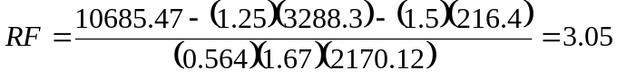

NRL
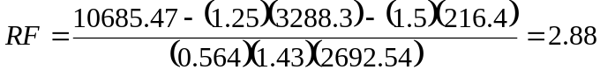

Rating for Flexure – Service III Limit State

The a live load factor of 1.0 (6A.5.4.2.2a)

Type 3-3
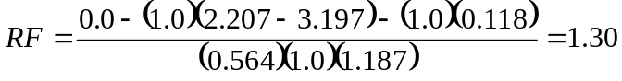

NRL
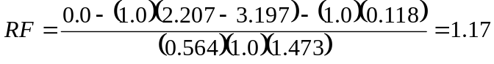

Rating for Shear – Strength I Limit State

Type 3-3
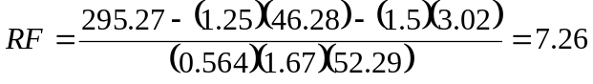
NRL
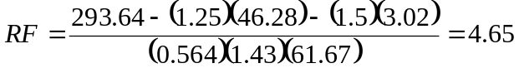

Rating in Tons (6A.4.4.4)
NRL controls – truck weight = 40 tons

Permit Load Rating – 6A.4.4.5

Assume routing (annual) permit (6A.4.5.3.1) since we are using the WSDOT BDM OL1 and OL2 loading.

Note: for spans between 200 and 300 ft, add a 0.2 klf lane load when checking negative moments in continuous structures (6A.4.5.4.1)

Load Factors (Table 6A.4.5.4.2a-1)
OL1 = 96 kips
OL2 = 207 kips

OL1
OL1 weighs less than 100 kips, interpolate between ADTT of 1000 and 5000
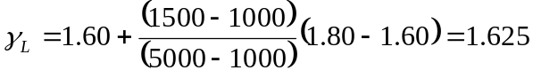
OL2
OL2 weighs more than 150 kips, interpolate between ADTT of 1000 and 5000
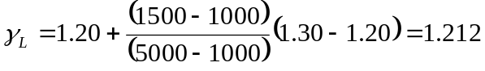
Note: If weight of rating vehicle is between 100 and 150 kips, a two way linear interpolation is required to get γ_{L}.

Note: If the length of the structure is less than the length of the vehicle, the weight of the vehicle used for determining γ_{L} is equal to the number of axles on the bridge at the time of the maximum force effect.

Live Load Distribution Factors
Moment
1 loaded lane, gM = 0.402
2+ loaded lanes, gM = 0.564

Shear
1 loaded lane, gV = 0.600
2+ loaded lanes, gV = 0.671

6A.4.5.6 – Exterior Beams
The live load distribution for exterior beams assumes permit trucks of equal weights are present in each lane.

Dynamic Load Allowance (6A.4.5.5)
Since this is a routine permit, assume that the vehicle is traveling at normal speeds. Dynamic load allowance is the same as for legal load rating.
IM = 33%

Note: If this is a slow moving load (≤ 10mph), IM may be taken as 0%.

Response
Per Lane | OL1 | OL2
Moment (k-ft) | 3106.88 | 5221.25
Shear (kip) | 75.91 | 115.16
φV_{n} (kip/girder) | 287.21 | 261.84
Note: PGSuper has to compute φV_{n} for each live load.

Rating for Flexure – Strength II Limit State

OL1
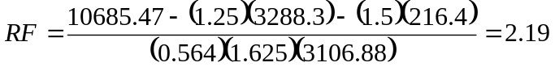

OL2
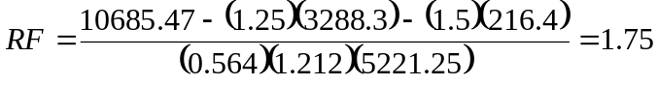

Rating for Shear – Strength II Limit State

OL1
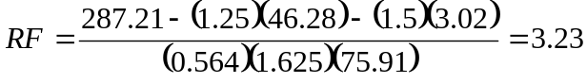
OL2
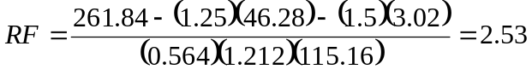

Check yield of prestressing steel (6A.5.4.2.2.b) at Service I Limit State
Note: This is an optional evaluation

Calculate stress in outer reinforcement at mid-span. Stress due to moments in excess of the cracking moment acts upon the cracked section. The moments up to the cracking moment cause stress in the reinforcement equal to the effective prestress.

Cracking moment, M_{cr} = 6685.18 k-ft
Moment in excess of cracking, M_{y} = M_{DW} + M_{DC} + M_{LL+IM} – M_{CR.}
M_{y} = 3288.29 + 216.36 + 5221.25 – 6685.18 = 2040.72 k-ft

Cracked Section Properties
Assume neutral axis is in the slab
Neutral axis location, 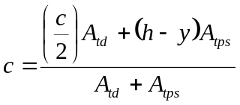
A_{td} = area of transformed deck = (c)(transformed effective flange width) = (c)(b_{t})
A_{tps} = area of transformed prestressing
h = height of section
y = distance from bottom of section to c.g. of prestressing

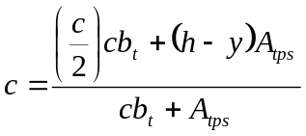
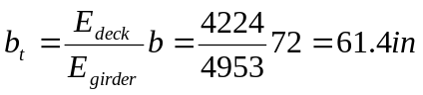
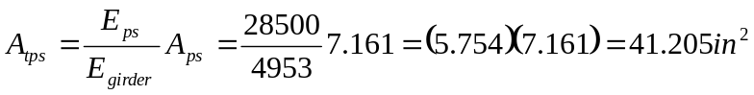
y = 3in
h = 66in + 7in = 73in
y_{bps} = 2 in (distance from bottom of girder to lowest strands)

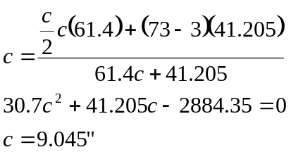

Neutral axis is in the girder

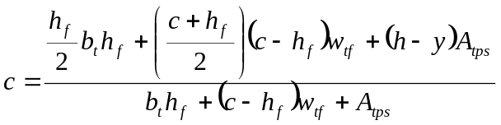
h_{f} = 7in
w_{tf} = 49in

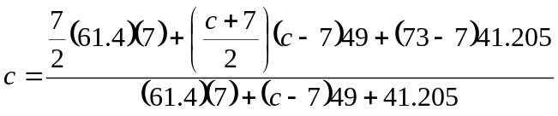
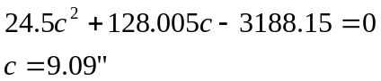

Cracked moment of inertia
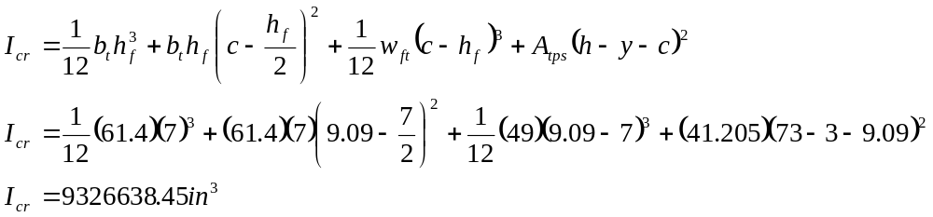

Note: PGSuper will need to implement a more general method of determining cracked section properties as the software operates on a general beam section. This could prove challenging.

Stress beyond effective prestress (increase in stress after cracking)

Effective Prestress

Stress in bottom strand during permit load crossing, Service I

Stress limit
Stress Ratio
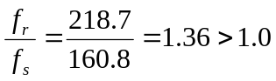 OK

Rating Summary

Limit State | Location | Design Load Rating  (HL-93) |  | Legal Load Rating |  | Permit Load Rating
Limit State | Location | Inventory | Operating | Type 3-3 | NRL | OL2
Strength I | Flexure (0.5L) | 1.85 | 2.40 | 3.05 | 2.88
Strength I | Shear (0.3L) | 2.13 | 2.76 | 7.26 | 4.65
Strength II | Flexure (0.5L) |  |  |  |  | 1.75
Strength II | Shear (0.3L) |  |  |  |  | 2.53
Service III | Flexure (0.5L) | 1.16 |  | 1.30 | 1.17
Service I | Flexure (0.5L) |  |  |  |  | Stress Ratio  1.36

Rating of Interior Girder
The rating of interior girders is the same as the rating for exterior girders with the exception of routine permit loading. MBE Table 6A.4.5.4.2a-1 says that routine permit trips with unlimited crossings are to be evaluating in a two or more lane with mixed traffic conditions. MBE 6A.4.5.6 puts additional requirements on the evaluation of exterior beams including the requirement that a multi-lane loaded condition shall be assumed and permit trucks of equal weights shall be assumed to be present in each line in determining the governing distribution factor.

Because of the requirements of MBE 6A.4.5.6, the evaluation of interior girders is different than exterior girders for the permit rating. The following illustrates the calculation procedure for an interior beam.

Live Load Distribution for interior beams and special permits (LRFD 4.6.2.2.5)

Response
Per Lane | OL1 | OL2 | HL-93
Moment (k-ft) | 3106.88 | 5221.25 | 3421.07
Shear (kip) | 75.91 | 115.16 | 77.2

Per girder response for OL1

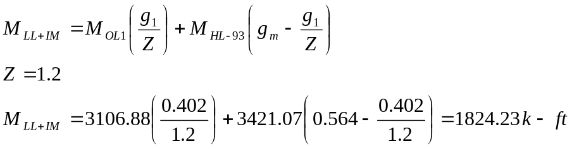

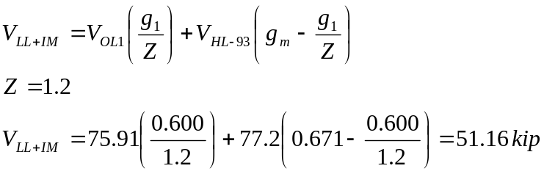

Per girder response for OL2

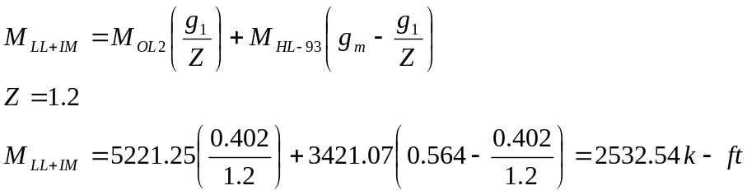

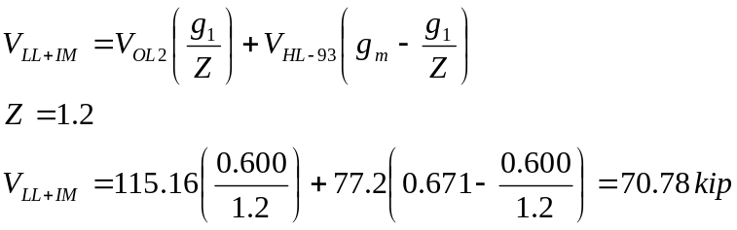

Shear Capacity at 0.3L under combined OL1 and HL-93 loading
Note: PGSuper doesn’t currently use this mixed loading analysis so it will be simulated here by determining equivalent live load distribution factors for the OL loading and then using the software to compute the shear capacity. PGSuper will need to be updated to compute live load effects for mixed loading types.

Equivalent gM for OL1 = 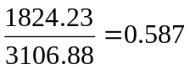
Equivalent gV for OL1 = 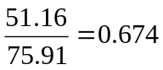
φV_{n} under OL1+HL-93 loading = 231.01 kip/girder

Equivalent gM for OL2 = 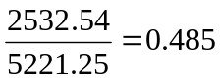
Equivalent gV for OL2 = 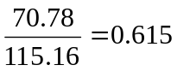
φV_{n} under OL2+HL-93 loading = 271.78 kip/girder

Rating for Flexure – Strength II Limit State

OL1
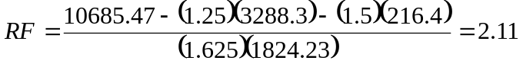

OL2
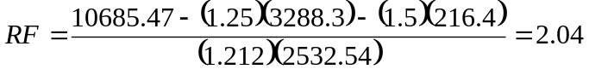

Rating for Shear – Strength II Limit State

OL1
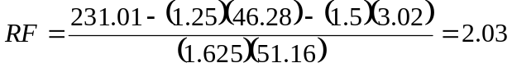
OL2
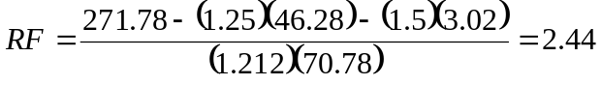

Example for Special Permit Vehicle

Exterior Girder Rating

Use the CalTrans P-13 vehicle for this example.
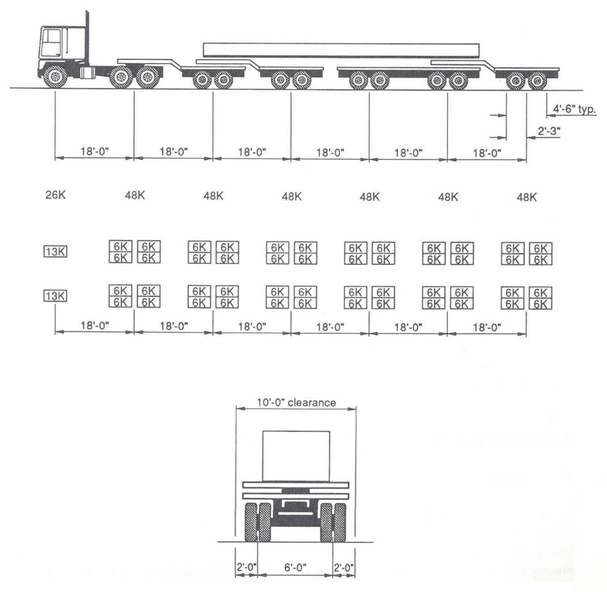

Assume this is an escorted vehicle

Live Load Factor (Table 6A.4.5.4.2a-1)
γ_{L} = 1.15

Live Load Distribution Factor
Use factor for one loaded lane with multiple presence factor removed (6A.4.5.6)
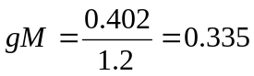
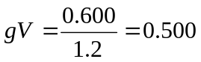

Dynamic Load Allowance
Assume a slow moving vehicle (< 10mph) – IM = 0%
P-13 response
M_{LL+IM} = 4375.54 k-ft (0.5L)
V_{LL+IM} = 87.88 kip (0.3L)
φV_{n} = 286.71 kip/girder

Rating for Flexure – Strength II Limit State

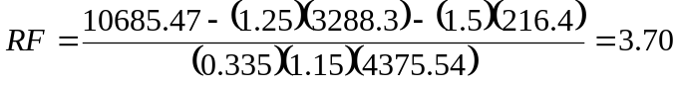

Rating for Shear – Strength II Limit State

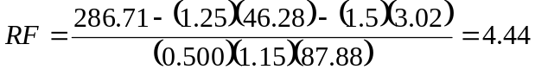

Check yield of prestressing steel (6A.5.4.2.2.b) at Service I Limit State
Note: This is an optional evaluation

Calculate stress in outer reinforcement at mid-span. Stress due to moments in excess of the cracking moment acts upon the cracked section. The moments up to the cracking moment cause stress in the reinforcement equal to the effective prestress.

Cracking moment, M_{cr} = 6685.18 k-ft
Moment in excess of cracking, M_{y} = M_{DW} + M_{DC} + M_{LL+IM} – M_{CR.}
M_{y} = 3288.29 + 216.36 + (0.335)(4375.54) – 6685.18 = -1714.7 k-ft

M_{y} < 0 ∴section will not crack under the P-13 loading

Example for Posting of Bridges (6A.8)
When the legal load rating for each AASHTO vehicle is greater than 1.0, the bridge need not be posted. A RF < 1.0 does not necessarily mean a bridge must be posted, as posting is a policy decision. Though not necessary for this structure, the safe posting loads will be computed for the educational benefit of the exercise.

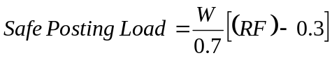

Posting Loads
Type 3, Type 3S2, Type 3-3, Type SU4, Type SU5, Type SU6 and Type SU7.

Load Factors
Routine Commercial Traffic (6A.4.4.2.3a)

For ADTT = 1500

Specialized Hauling Vehicles (6A.4.4.2.3b)

For ADTT = 1500

IM = 33% (assume same as legal load rating)

Live Load Distribution Factor, gM = 0.564 and gV = 0.671 (computed by PGSuper – assume same as legal load rating).

Per Lane | Weight (ton) | Load Factor | Moment @ 0.5L (k-ft) | σ_{b} @ 0.5L (ksi) | Shear @ 0.3L (kip) | φV_{n} @ 0.3L (kip/girder)
Type 3 | 25 | 1.67 | 1700.13 | 0.930 | 42.23 | 298.44
Type 3S2 | 36 | 1.67 | 2107.9 | 1.153 | 51.48 | 294.58
Type 3-3 | 40 | 1.67 | 2170.12 | 1.187 | 52.29 | 295.27
Type SU4 | 27 | 1.43 | 1858.64 | 1.017 | 46.23 | 299.42
Type SU5 | 31 | 1.43 | 2109.44 | 1.154 | 52.01 | 297.52
Type SU6 | 34.75 | 1.43 | 2344.37 | 1.282 | 56.27 | 295.75
Type SU7 | 38.75 | 1.43 | 2599.55 | 1.422 | 60.49 | 294.09

Safe Posting Loads

Type 3
Strength I - Moment 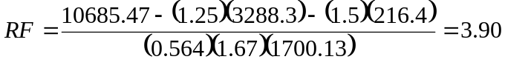

Strength I - Shear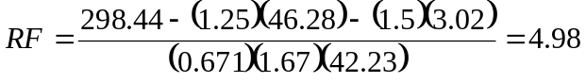

Service III 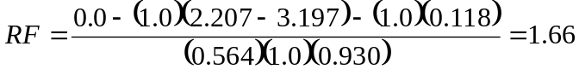

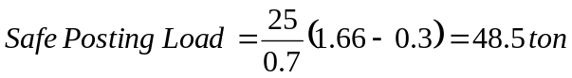

Type 3S2
Strength I - Moment 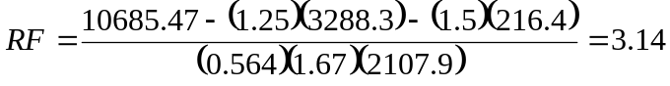

Strength I - Shear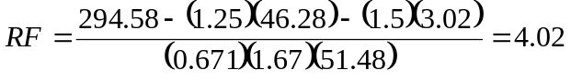

Service III 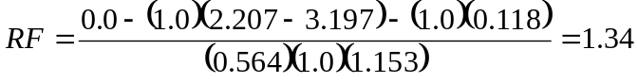
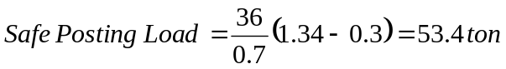

Type 3-3
Strength I - Moment

Strength I - Shear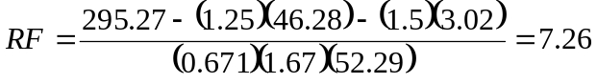

Service III
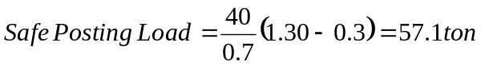

Type SU4
Strength I - Moment 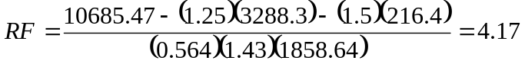

Strength I - Shear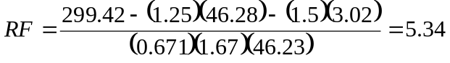

Service III 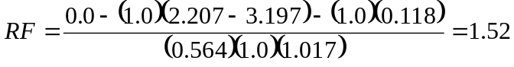
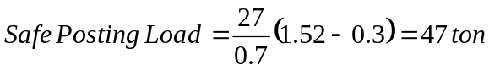

Type SU5
Strength I - Moment 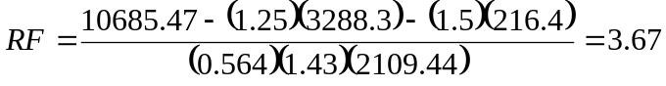

Strength I - Shear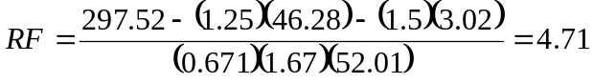

Service III 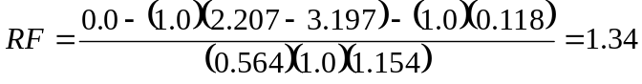


Type SU6
Strength I - Moment 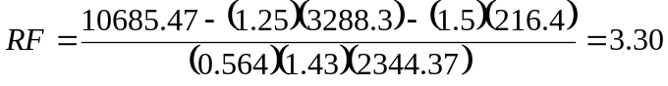

Strength I - Shear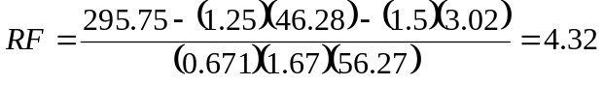

Service III 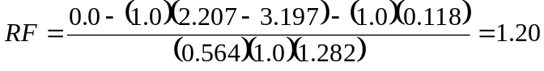
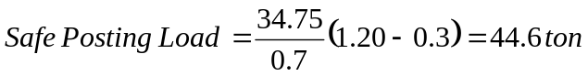

Type SU7
Strength I - Moment 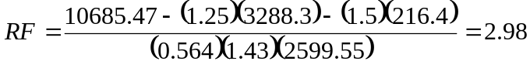

Strength I - Shear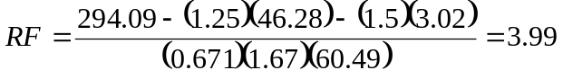

Service III 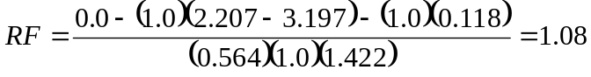
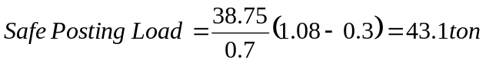

Summary
 | Truck Weight (ton) | RF | Safe Load Capacity (ton) | Safe Posting Load (ton)
Type 3 | 25 | 1.66 | 41.5 | -
Type 3S2 | 36 | 1.34 | 48.2 | -
Type 3-3 | 40 | 1.30 | 52 | -
Type SU4 | 27 | 1.52 | 41 | -
Type SU5 | 31 | 1.34 | 41.5 | -
Type SU6 | 34.75 | 1.20 | 41.7 | -
Type SU7 | 38.75 | 1.08 | 41.8 | -

Example for Negative Moment Rating
Extend our sample bridge to a two span continuous structure (2 spans @ 120ft = 240ft).
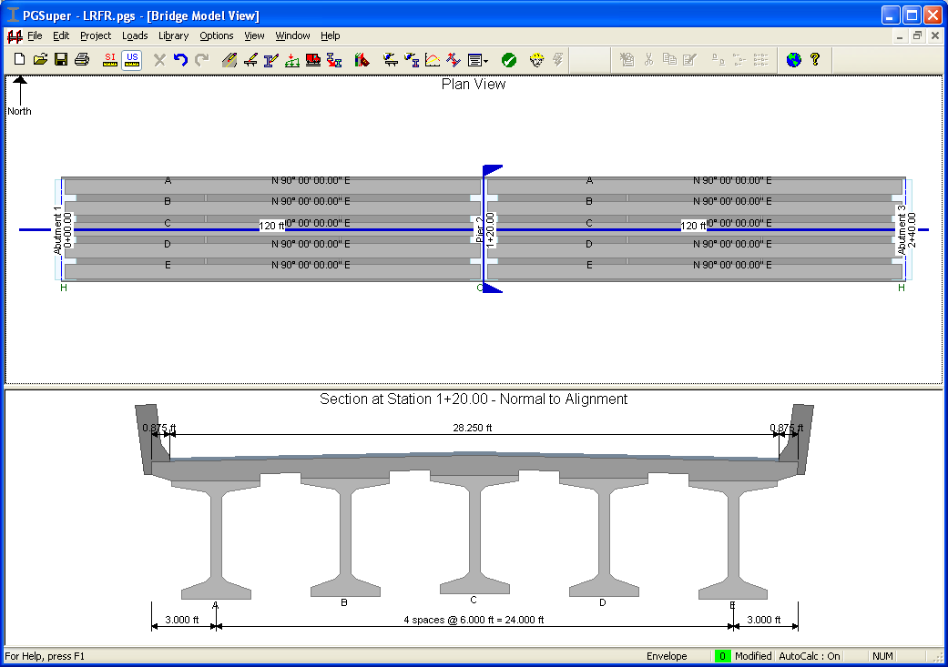

Design Rating – MBE 6A.4.3.1

6A.5.4.1 – Rate at the Strength I limit state

Rating for Flexure

Rating location = Pier 2

System Factor, φ_{s} = 1.0 (Table 6A.4.2.4-1, All other girder bridges and slab bridges)

Moments
M_{DC} = -308.54 k-ft
M_{DW} = -216.36 k-ft
M_{LL+IM} = -1560.47 k-ft/girder (HL-93 loading)

Load Factors – Strength Limit State (MBE 6A.4.2.2)
γ_{DC} = 1.25
γ_{DW} = 1.50 (wearing surface not field measured – would be 1.25 if it was field measured 6A.2.2.3)
γ_{LL} = 1.75 for Inventory (6A.4.3.2.2)
γ_{LL} = 1.35 for Operating (6A.4.3.2.2)

Dynamic Load Allowance = 33% (MBE 6A.4.3.3 and LRFD 3.6.2) – Already included in M_{LL+IM} above.

Live Load Distribution Factor, gM = 0.564 (computed by PGSuper, included in M_{LL+IM} above).

Moment Capacity, 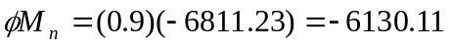k-ft (computed by PGSuper)

6A.5.7 – Minimum reinforcement
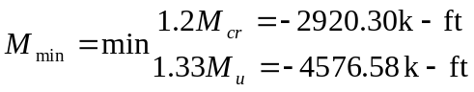
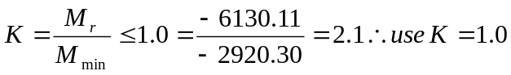

Rating Factor
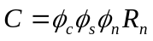 Strength I limit state

Inventory Rating – Strength I Limit State
k-ft

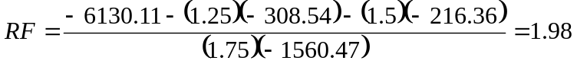

Operating Rating – Strength I Limit State
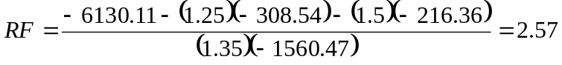

Legal Load Rating – 6A.4.4

Span Length = 240 ft (interpreted as bridge length), therefore use 75% of Type 3-3 with 0.2 KLF lane load

This is a negative moment evaluation so also use 75% of 2-Type 3-3 separated by 30 ft and a 0.2 KLF lane load.

Note: If ADTT is less than 500, use 100% of Type 3-3 and remove the lane load

Per Lane | Type 3 | Type 3S2 | Type 3-3 | Type 3-3 w/ Lane | Dual Type 3-3 w/ Lane | NRL
Moment  (k-ft) | -714.30 | -970.73 | -1028.91 | -1098.45 | -1815.71 | -1140.30

Dynamic Load Allowance (6A.4.4.3)
IM = 33%

Note: IM could be 10% or 20% based on riding surface condition (see C6A.4.4.3)

Load Factors
Strength I Limit State – Routine Commercial Traffic (6A.4.4.2.3a)

For ADTT = 1500

Strength I Limit State – Specialized Hauling Vehicles (6A.4.4.2.3b)

For ADTT = 1500

Rating for Flexure – Strength I Limit State

Dual Type 3-3 w/ Lane
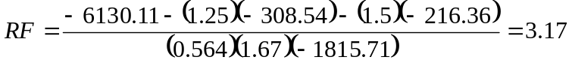

NRL
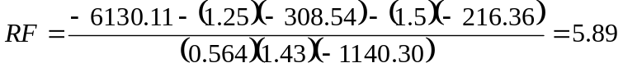

Permit Load Rating – 6A.4.4.5

Assume routing (annual) permit (6A.4.5.3.1) since we are using the WSDOT BDM OL1 and OL2 loading.

Because the bridge is between 200 and 300 ft, we add a 0.2 KLF lane load when applying the OL vehicles for negative moment (6A.4.5.4.1)

Load Factors (Table 6A.4.5.4.2a-1)
OL1 = 96 kips
OL2 = 207 kips

OL1
OL1 weighs less than 100 kips, interpolate between ADTT of 1000 and 5000
OL2
OL2 weighs more than 150 kips, interpolate between ADTT of 1000 and 5000
Note: If weight of rating vehicle is between 100 and 150 kips, a two way linear interpolation is required to get γ_{L}.

Live Load Distribution Factors
gM = 0.564

6A.4.5.6 – Exterior Beams
The live load distribution for exterior beams assumes permit trucks of equal weights are present in each lane.

Dynamic Load Allowance (6A.4.5.5)
Since this is a routine permit, assume that the vehicle is traveling at normal speeds. Dynamic load allowance is the same as for legal load rating.
IM = 33%

Note: If this is a slow moving load (≤ 10mph), IM may be taken as 0%.

Response
Per Lane | OL1 | OL1+Lane | OL2 | OL2+Lane
Moment (k-ft) | -1355.36 | -1682.12 | -2527.36 | -2854.12

Rating for Flexure – Strength II Limit State

OL1 + Lane
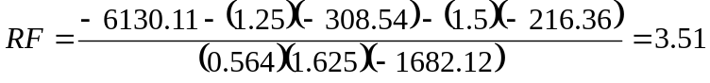

OL2 + Lane
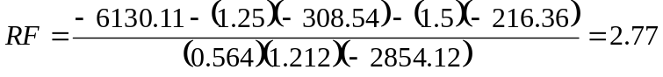

Check yield of deck reinforcing (6A.5.4.2.2.b) at Service I Limit State
Note: This is an optional evaluation

Calculate stress in outer reinforcement at pier 2. The Service I moments act upon the cracked section to produce stress in the reinforcement. An elastic model of the cracked concrete section with transformed steel is used to calculate the stress in the reinforcement due to the Service I loads.

Cracked Section Properties
Assume neutral axis is in bottom flange of girder

Neutral axis location, 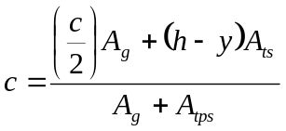
A_{g} = area of girder in compression (bottom flange) = (c)(bottom flange width) = (c)(w_{bf})
A_{tps} = area of transformed deck reinforcing
h = height of section
y = distance from bottom of section to c.g. of prestressing

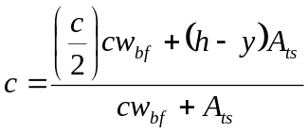
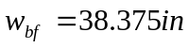

Deck Reinforcement – Top Mat 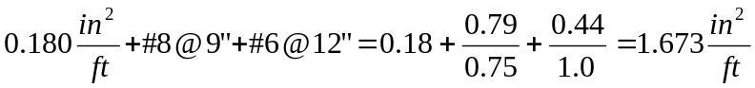

Deck Reinforcement – Bottom Mat 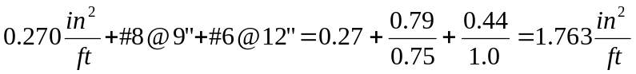
Effective flange width = 72in = 6ft
Total Deck Reinforcement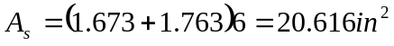
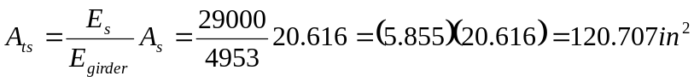

Distance from top of deck to CG of reinforcing
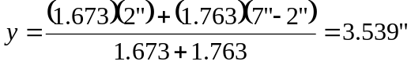

h = 66in + 7in = 73in
y_{ts} = 2 in (distance from top of deck to highest layer of deck rebar)

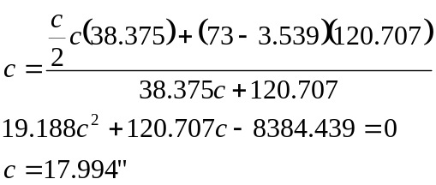

The bottom flange is approximately 9” thick, therefore the assumption is incorrect. The neutral axis is in the web.

Neutral axis in web

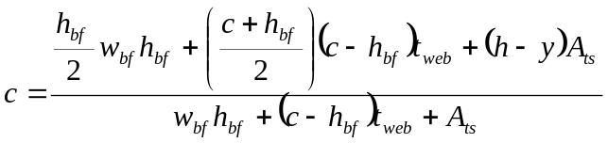
Let h_{bf} = 9in (the bottom flange is actually a trapezoid, but this is close enough for the sake of example)
t_{web} = 6.125in

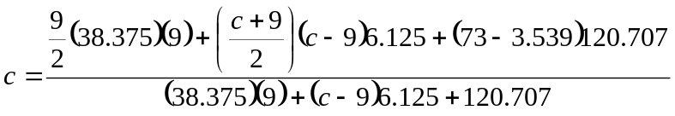
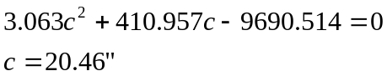

Cracked moment of inertia
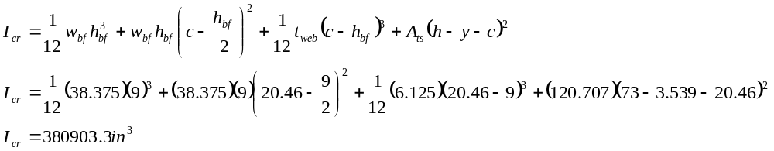

Note: PGSuper will need to implement a more general method of determining cracked section properties as the software operates on a general beam section. This could prove challenging.

Stress in the extreme tension reinforcement

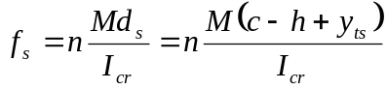
Stress due to dead loads
M_{DC} = -308.54 k-ft
M_{DW} = -216.36 k-ft

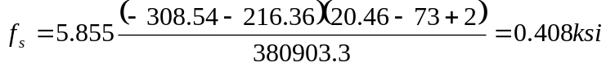
Note: MBE uses 2n for dead loads when compute stress and Icr. We used 1n here. Investigate why 2n and if PGSuper should use 2n.

M_{LL+IM}=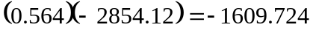k-ft
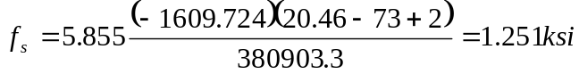

Stress in top mat of deck reinforcing
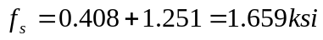

Stress limit
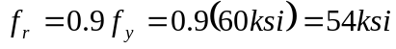
Stress Ratio
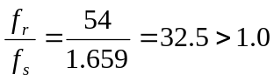 OK

